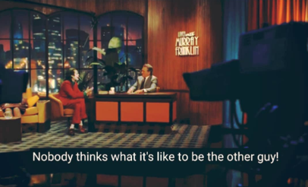
Would you rather live in a society, that understands too much,cares to much, is highly sensitive, does not believe in hierarchy, is free of all prejudice, free of all schools of thought,promises and fights for equality, but is dysfunctional, because of the fact that it fails to take action as it manages to find a reason behind every act a man commits,Or, would you choose to be in the world as it is, without change?

●All concepts of relativity, are true, and everything is relative indeed. You kill a chicken and call it food,you kill a human and call it murder.This is specism, a form of discrimination, just like racism and sexism.

The lack of advanced intellectual prowess in a chicken puts killing it on a more morally neutral ground than killing a human.That should mean killing grown ups is morally worse than killing infants or people with alzhimers? But that isn't the case,is it?

All that you care about is your emotional response to a stimulus and killing a human instigates more emotion in you than killing a chicken, for you can relate,understand, and know of the danger this act poses to yourself if it becomes frequent.

If you were to feel the same fear and emotion due to a killed chicken,you might as well fight for chicken rights.

Consider everyone is sensitized towards chicken, and does not kill it,but a religion has it that killing chicken is important for them, and again, a sect of secular people rise, saying it's the personal right of the people to exercise their negative freedom, if it does not affect other humans, citing it is morally incorrect to violate someone's religion, what would this society do?

Two moral questions, overlapping, both having arguments strong enough, one being a question of specism and other, of religious liberty, both having opposite solutions.

What would a truly "understanding" society do,if it didn't want to remain dysfunctional?

What would it choose to be its moral compass?

Remember this point,this proposed world wants true equality.

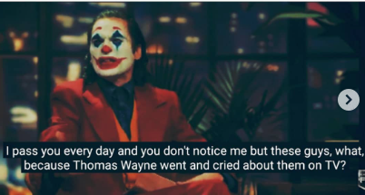
The answer is, one of the sects will have to compromise,to avoid conflict, and that, isn't inequality, but sanity.
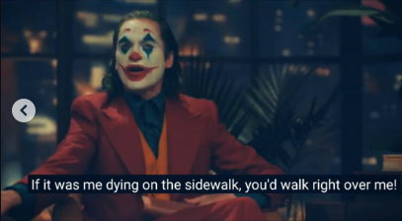

The compromise will either hurt the chicken saving majority, or the chicken killing minority. The saving majority, if extreme enough, could decide to eradicate and convert the minority, violating one moral for another.
The concept of removing specism,stemming from non-violence,and respect for other creatures, mutating into violence, that of vegetarian majority against non-vegetarian minority.
Again, a case of morale overlapping, but here,the same morale is in question, and its "defence" relies on violating it, giving the life of a chicken more importance than the life of a person. •This is just an example of how extreme righteousness can mutate and take forms which contradict itself.

The moment your emotions are hurt,your righteousness converts into self justification,and understanding converts into ignorance.
Emotion and understanding gave the chicken protection, now the same chicken, is taking them away from the people,in a different form.

The search for utopia, of a world of true understanding, of true equality, will always fail because of overlapping and conflicting morales, of problems of choice, and without compromise, none will be resolved.

